17 Water, Wet Fines and Repeated Wetting Exposure
Water can change the way fines and deposited material behave once they leave the intended process route. Where process or cleaning water comes into contact with loose fines, the material can become wet or slurry-like and may be redistributed beyond the immediate area in which it was first released. This can increase housekeeping demand and expose nearby equipment and structures to repeated wetting.
The inspection record identifies several ways in which water may be introduced at different parts of the plant, including dust-suppression sprays, hose cleaning and high-pressure water used under some blockage or silo conditions. These are location-specific operating examples and should not be assumed to apply to every area where water or wet fines are visible. At CV01 and CV04, the photographs show wet-fines/slurry conditions, but the initiating water source has not been established from the available evidence. At the Screens, considered in the following section, operating video provides a stronger basis because active process-water escape was directly observed. Repeated wetting may be relevant to continued equipment and structural exposure, but it should not on its own be used to assign the cause of corrosion or deterioration.

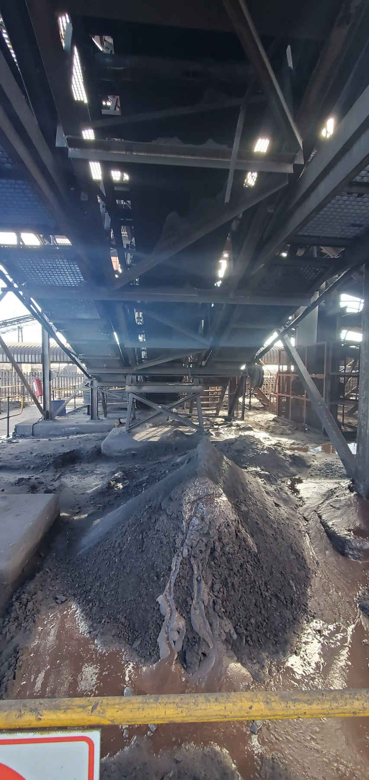  CV01-REF-003 — Wet-fines/slurry accumulation with pooled water beneath the conveyor area. The photograph shows the wet condition, while the initiating water source remains unresolved. | 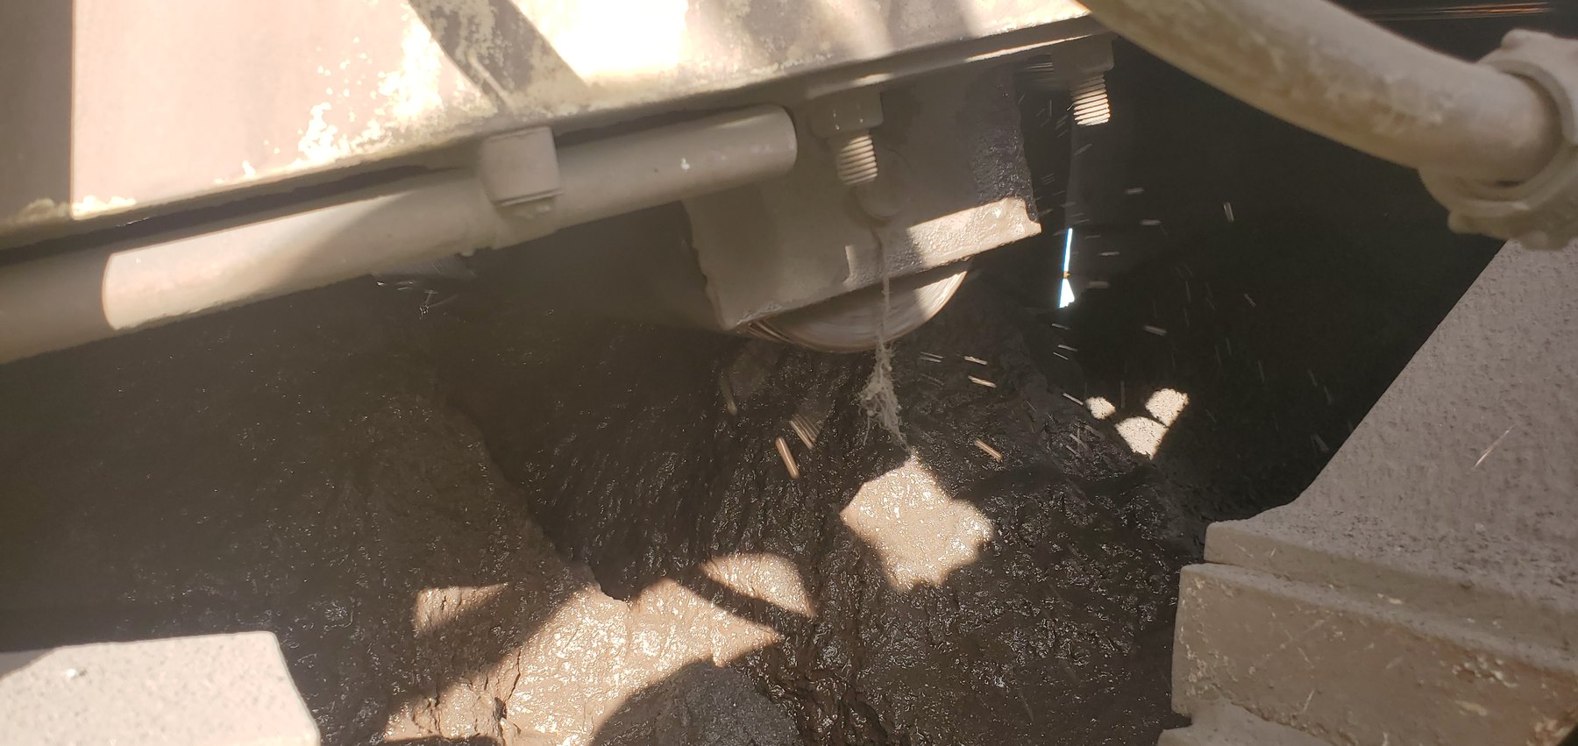  CV04-REF-002 — Saturated wet-fines/slurry accumulation beneath CV04, with visible wet fallout/droplet evidence in the local area.
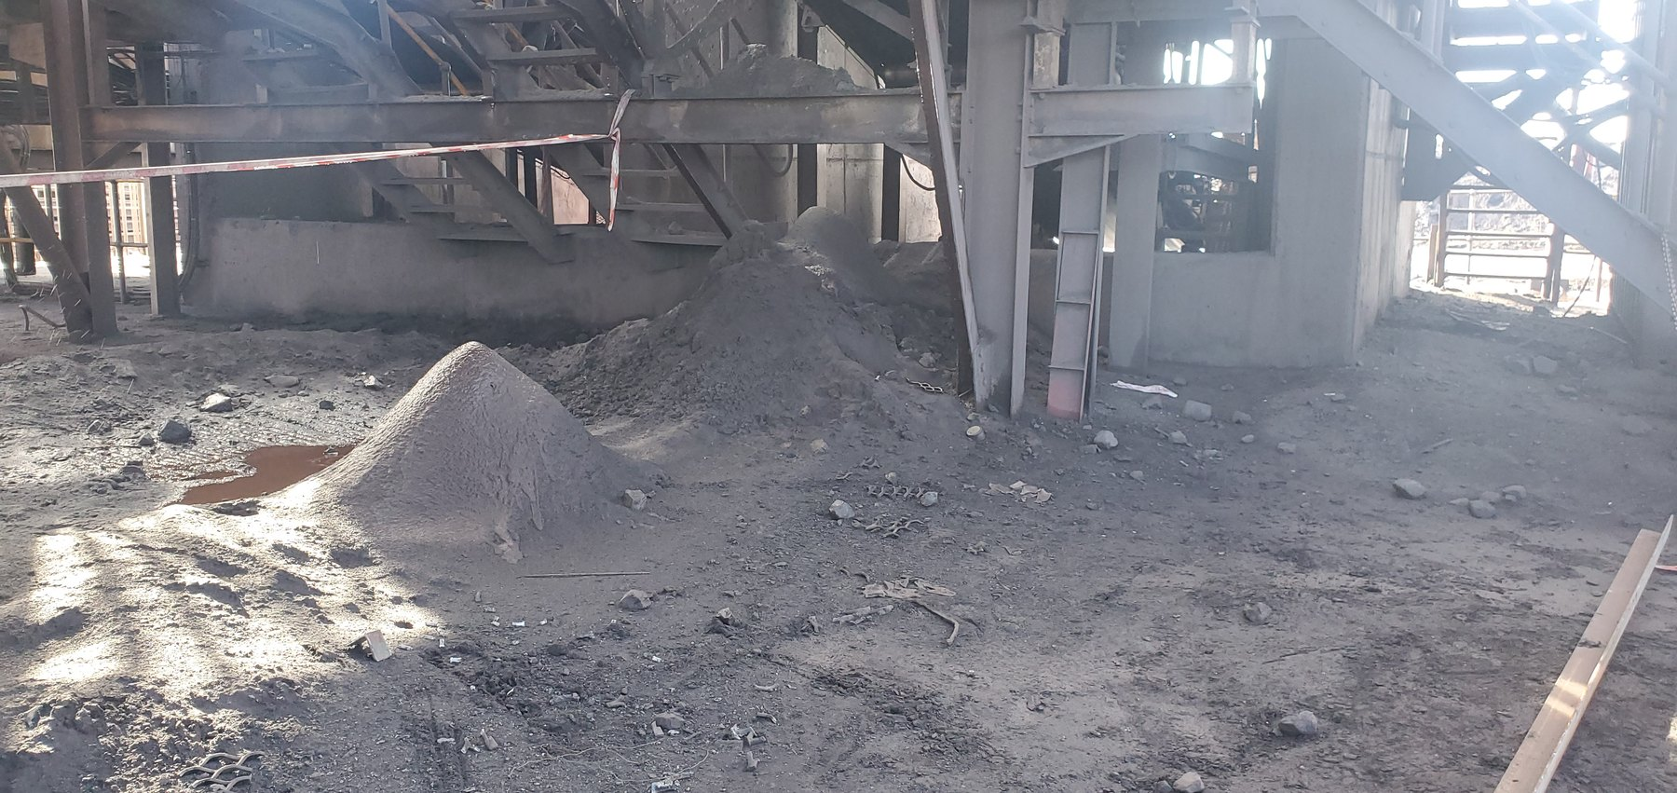
CV04-REF-005 — Wider view showing multiple fines accumulations beneath and around CV04, illustrating the broader distribution of material at this location.

